Monuments breaker.

Realization:

When we chose the theme of our Expolangue this stand was one of our first ideas. The goal was to make a real clash between the two sides. It was linked to one other idea which was to make a stand with different typical small game, but this idea was replaced by the dart game stand. After few researches we found that the equivalent of the French “Chamboule Tout” was the “Coconut Shy”.

A coconut shy (or coconut shie) is a traditional game frequently found as a side stall at funfairs and fêtes. A player buys three wooden balls, throws them at a row of coconuts balanced on posts and wins each coconut successfully dislodged. In some cases other prizes maybe won instead of the coconuts. But coconuts were too expensive and less easy to find so we decided to make it in a different way. So we decided to use the French version.

In France, the game is called “Chamboule-Tout”.A Player throw 3 balls balls at empty tins. It’s very popular on school-parties called “Kermesse” were most of time the balls are curled socks. In German-speaking countries is called “Dosenwerfen” and is some time played in a professional way on fairs. So we started thinking how to create the perfect “Chamboule-Tout”. In the first time we decided to build “The Eiffel Tower” and “Buckingham Palace”. I was chosen to do everything linked to this activities when we make the team and chose roles.

Building the monuments wasn’t the hardest part of the job! It was to find how make monuments with tins and found theses tins. Thanks to our Client who gave us the tins I used, I had time to realise the monuments. When I was building the Eiffel Tower I realise that it was easier to build something high. So I took the “Big-Ben” instead of the “Bucking Palace”. I also had to say few things about the monuments when people won the game so I made researches and create small cards (and posters too):

Name: Big Ben
Date: 1858
Construction Time: 1843-1859(Part of a huge project)
Main contractor Charles Barry
Notes:
- Largest four-faced chiming clock
-Third-tallest free-standing clock tower in the world.
-Big Ben is actually the nickname of the largest bell in the tower: the Great Bell
- Symbol of the United Kingdom and London, particularly in the visual media
-The clock and dials were designed by Augustus Pugin.
- The clock chimes midnight to celebrate the new years. It’s a famous event in England.
Name: The Eiffel Tower
Date: 1889
Construction Time: 2 Years
Main contractor Gustave Eiffel
Notes:
-Tallest in the world from 1889 to 1930
-3 Levels, Restaurants, Elevators
-More than 200,000,000 people have visited the tower since its construction in 1889, including 6,719,200 in 2006.The tower is the most-visited paid monument in the world
-Hitler conquered France, but did not conquer the Eiffel Tower

Reproduce/inspiration:
-Blackpool Tower (Blackpool-England)
-Tokyo Tower (Tokyo-Japan)
-Eiffel Tower (Las Vegas, Nevada-USA)

During The Expolangue:

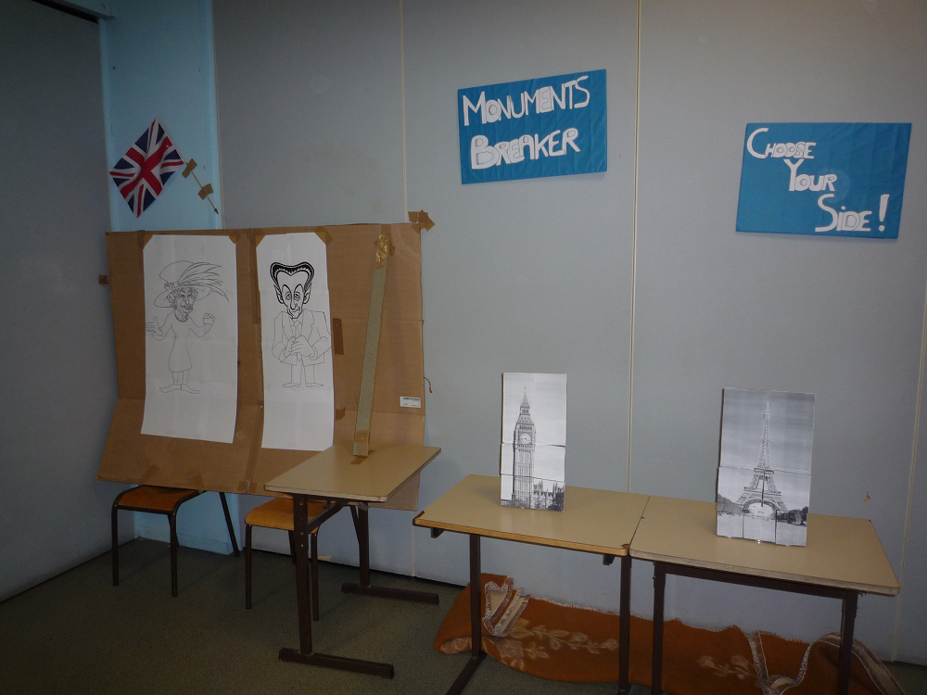

This stand was just next to the dart game, so visitors will have a double chance to choose their side between France and England; personally I had already chosen my side by dressing as the typical Frenchman. But instead of the dart game, my stand doesn’t seem to be obvious to the visitors. So I spent most of my time attracting people to the Stand or explaining them what to do. I realise that people doesn’t read the poster I have made and pasted on the wall or that there were not clear enough.
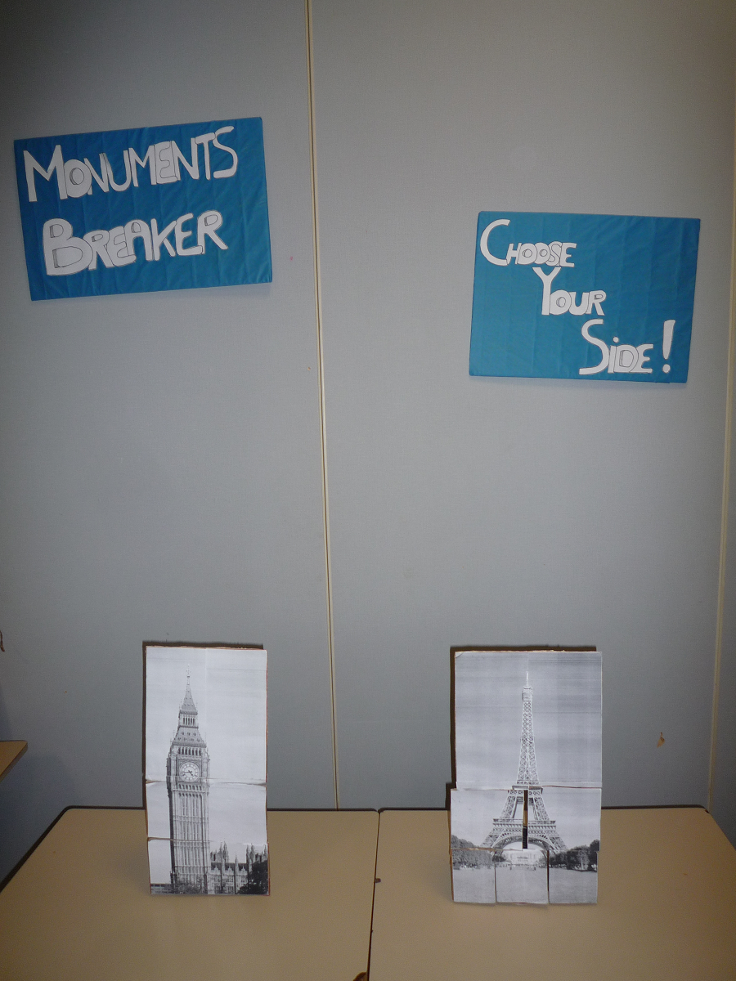

Despite the fact that a lot of people don’t try my stand because I was already busy explaining to other people, it had some success. In the beginning I tried to count the number of destruction for each monument but I lost the count after about 1 hour, but Big Ben was the most destroyed. Generally they listened to my short indications about the monument they had just destroyed and then switched to the next stand. Only few people were enough interested to read the poster I made about the monuments with more information. Some people have described my stand as “Cool” or “Really Fun”. I appreciate those comments because they were the reward for my work on this project

Realizing and running this project was a real challenge for me. I had to overcome my shyness. It took me a short time to adapt myself and be able to speak spontaneously with the visitors. That was also my first real teamwork (with a team bigger than 5 people).

